1.Bucket created with name vickybucket2025

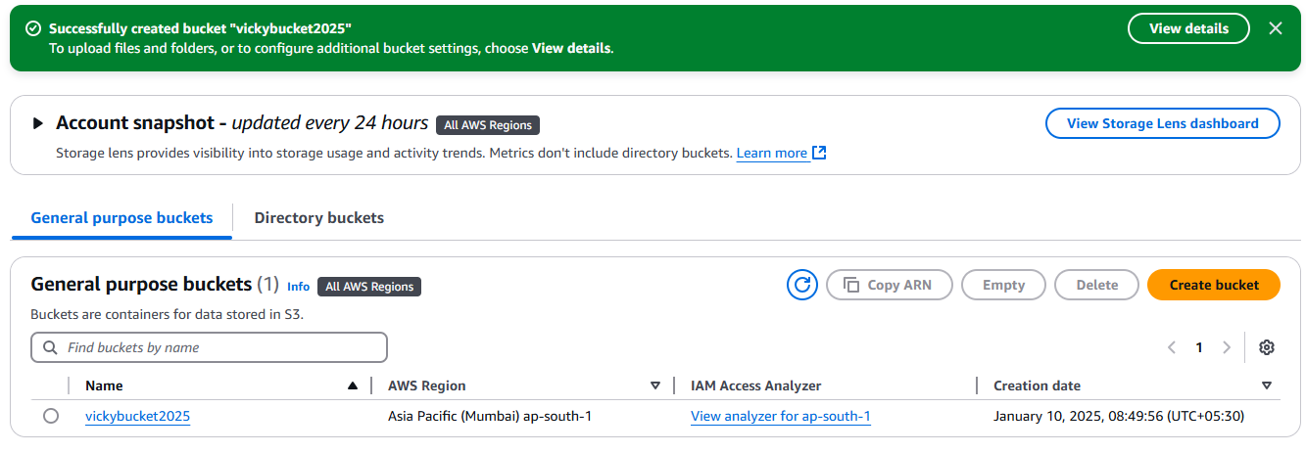

2.Uploaded some files in bucket

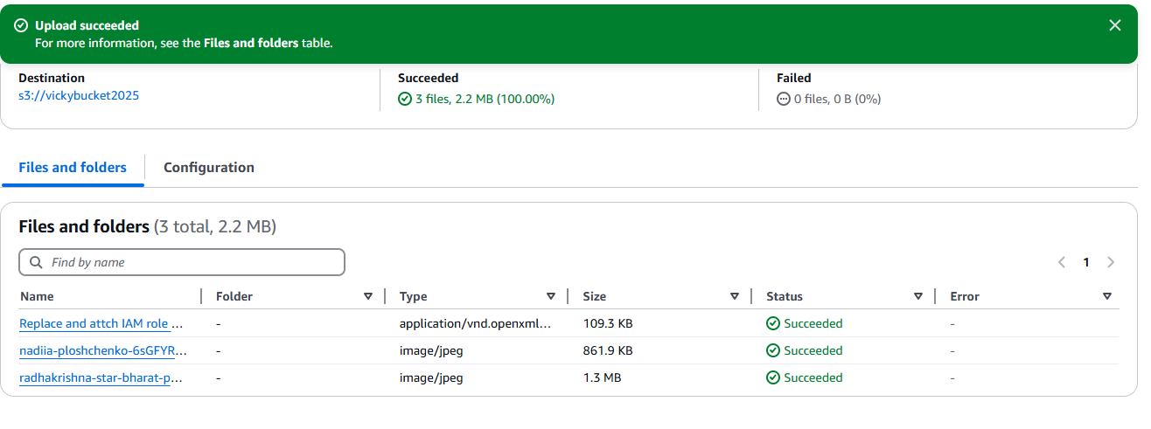

3.Initially object was denied to access the URL in bucket as object level permission is private

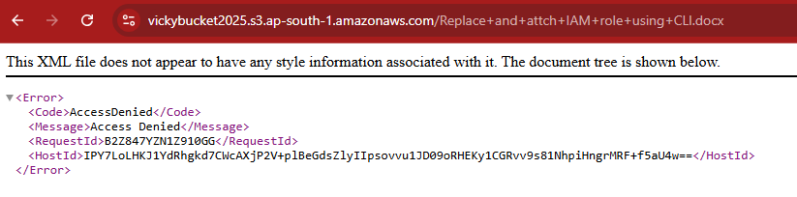

4.provided object level permission and we can access the object now

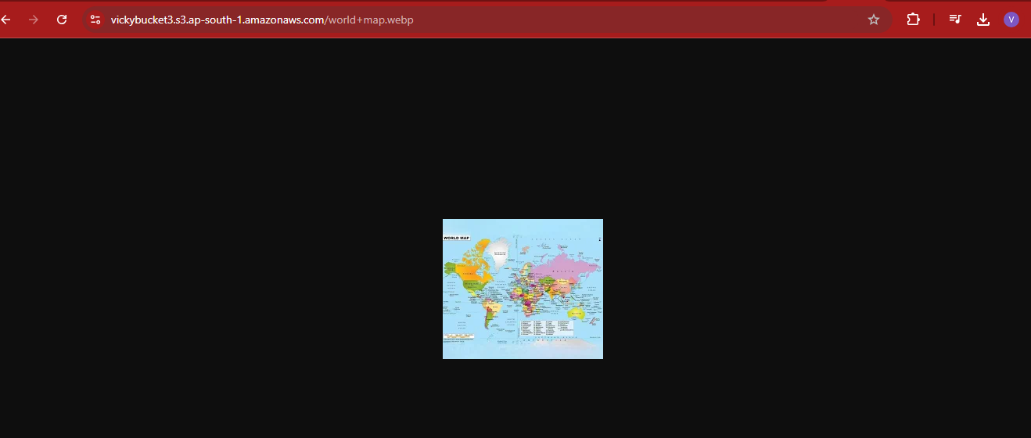

5.